FemAura-AI Partner For Menstrual
Health

Shresta Padmanabh Rai¹
Department of Computer
Applications,
St. Joseph Engineering College,
Mangaluru, Karnataka, India

Ms. Lavanya Shetty²  Assistant Professor  Department of Computer Applications,  St. Joseph Engineering College,  Mangaluru, Karnataka, India |  | Dr. Hareesh B³  Head of the Department  Department of Computer Applications,  St. Joseph Engineering College,  Mangaluru, Karnataka, India

Abstract
Women often face difficulties in monitoring menstrual health due to irregular lifestyles, stress, and lack of personalized health insights. This paper presents FemAura, an AI-based menstrual health monitoring system designed to provide personalized cycle tracking, health analysis, and prediction support based on user inputs such as cycle dates, flow intensity, mood changes, and symptoms. The system uses artificial intelligence and data-driven techniques to identify irregular patterns, predict upcoming cycles, and generate meaningful health reports. It also assists in the early detection of possible hormonal imbalances such as PCOS and PCOD through symptom trend analysis. The application is developed as a secure web-based platform with an intuitive interface that enables users to easily manage and track menstrual health data. The results indicate that the proposed system can improve health awareness, support informed decision-making, and has the potential for further enhancement using advanced AI technologies.

Introduction
In recent years, digital healthcare technologies have improved personal health monitoring and awareness. Menstrual health, which is closely related to a woman’s overall physical and hormonal well-being, often receives limited attention due to irregular lifestyles, stress, and lack of personalized guidance. Many existing menstrual tracking applications mainly focus on basic cycle prediction and do not provide deeper analysis of menstrual patterns or early identification of conditions such as PCOS and PCOD.
Traditional menstrual tracking methods usually depend on manual calculations or simple calendar-based applications that may not provide accurate and personalized insights. In addition, cycle tracking, symptom analysis, prediction, and health reporting are often separated across different platforms, reducing the effectiveness of health monitoring. A more intelligent and integrated solution is needed to help users better understand menstrual patterns and reproductive health.
With advancements in artificial intelligence and web technologies, it has become possible to develop systems that analyze menstrual data and generate meaningful predictions and health insights. AI-based systems can evaluate factors such as cycle duration, flow intensity, mood changes, and symptoms to detect irregularities and provide personalized reports. These technologies can support users in improving menstrual health awareness and making informed healthcare decisions.
This paper presents FemAura, an AI-powered menstrual health monitoring system designed to provide intelligent cycle tracking, prediction, and health analysis. The system allows users to record menstrual details and uses analytical techniques to identify irregular patterns and possible indicators of PCOS and PCOD. The application is developed as a secure web-based platform with a simple and user-friendly interface that helps users efficiently track cycles, manage health records, and improve awareness of reproductive health.

literature review
Lee et al. (AI-Based Menstrual Cycle Prediction System) proposed a machine learning-based menstrual prediction model that analyses previous cycle data to improve prediction accuracy [1]. Their work demonstrated that AI techniques can provide better menstrual forecasting compared to traditional calendar methods. However, the system mainly focuses on prediction and does not support detailed symptom analysis or reproductive health monitoring.
Riga et al. (Digital Menstrual Health Applications) studied the effectiveness of menstrual tracking applications in improving reproductive health awareness [2]. The research highlighted that digital health platforms help users maintain menstrual records and monitor cycle changes. However, most applications provide only basic tracking features and lack intelligent health analysis capabilities.
Sharma et al. (Machine Learning Approaches for PCOS Prediction) proposed a machine learning model for identifying PCOS symptoms using health and hormonal data [3]. The study showed that AI models can assist in the early detection of hormonal disorders with improved accuracy. However, the work mainly focused on clinical datasets and was not integrated into a real-time user-friendly application.
Patel et al. (Women’s Health Monitoring Systems) reviewed different healthcare technologies used for women’s reproductive health monitoring [4]. Their study emphasized the importance of personalized healthcare systems and intelligent prediction models. However, existing systems often fail to combine symptom tracking, menstrual prediction, and health analysis into a single platform.
Kumar et al. (AI in Healthcare Monitoring Applications) explored the role of artificial intelligence in personal healthcare monitoring systems [5]. The research highlighted how AI can analyze user data to identify health patterns and generate personalized insights. However, many applications still lack practical implementation for menstrual and reproductive health management.
Chen et al. (Deep Learning Techniques for Menstrual Health Prediction) proposed a deep learning-based system for analyzing menstrual cycle patterns and predicting irregularities using historical user data [6]. The study demonstrated that deep learning models can improve prediction accuracy and assist in identifying abnormal cycle behaviors. However, the system mainly focused on prediction accuracy and did not include detailed health reporting or symptom analysis features
Ahmed et al. (Smart Healthcare Systems for Women’s Reproductive Health) developed a smart healthcare monitoring system that collects and analyzes reproductive health data to provide personalized insights [7]. Their research highlighted the importance of integrating AI technologies into women’s healthcare applications for better monitoring and early risk detection. However, the system lacked advanced menstrual cycle prediction and long-term trend analysis capabilities.
Gupta et al. (Mobile Health Applications for Menstrual Tracking and Awareness) reviewed various mobile health applications designed for menstrual cycle tracking and reproductive health education [8]. The study emphasized that digital health applications improve user awareness and engagement in menstrual health management. However, many applications still rely on simple tracking methods and fail to provide intelligent analysis for conditions such as PCOS and PCOD.
From the analysis of these studies, it is evident that most existing systems focus mainly on basic menstrual tracking, prediction, or separate health monitoring features. There is a lack of integrated systems that combine menstrual tracking, symptom analysis, AI-based prediction, and early identification of PCOS and PCOD into a single platform. The proposed FemAura system addresses this gap by providing an intelligent and user-friendly menstrual health monitoring solution that supports personalized tracking, health analysis, and reproductive health awareness.

methodology
The proposed FemAura system follows a structured and intelligent approach to provide menstrual health monitoring, cycle prediction, and reproductive health analysis. The methodology is designed to process user menstrual data efficiently and generate meaningful health insights and predictions. The overall workflow of the system consists of multiple stages, including data collection, data processing, pattern analysis, prediction generation, and health report management. Each stage plays an important role in ensuring accurate analysis and a smooth user experience.
+
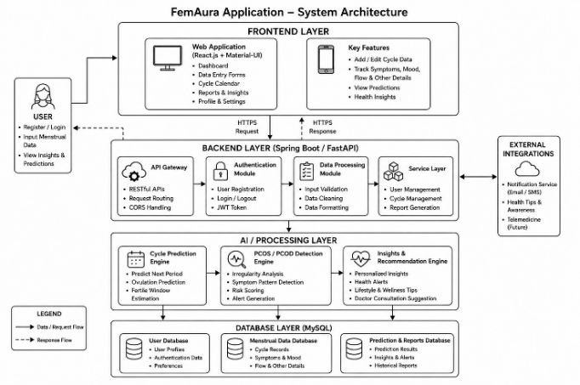
Fig 1: System Architecture

The system architecture consists of four main components: frontend, backend, AI processing, and database layers. Users interact with the system through a React.js and Material-UI based interface, where menstrual details such as cycle dates, symptoms, flow intensity, and mood variations are entered as shown in [Fig 1]. The data is processed through Spring Boot/FastAPI-based APIs, while the AI layer performs cycle prediction and PCOS/PCOD analysis. MySQL is used for secure data storage, and the generated predictions and health insights are displayed to the user through the frontend interface

.Data Collection

The first stage of the system involves collecting menstrual health information through a simple and user-friendly interface. The frontend, developed using React.js with Material-UI, allows users to enter details such as cycle dates, flow intensity, mood variations, and symptoms. These inputs are important for analyzing menstrual patterns and generating personalized predictions and health insights. The interface is designed to be responsive and easy to use, enabling users to quickly record and manage their menstrual health data.

Data Processing
After collecting the user inputs, the data is sent to the backend for processing and analysis. The backend is implemented using Spring Boot/FastAPI-based REST APIs, which handle data validation and system operations. In this stage, the entered data is checked for missing or incorrect values and then organized for further analysis. This process ensures reliable system performance and improves the accuracy of predictions and reports.

Recommendation Engine
The prediction and analysis engine is the core component of the FemAura system. The AI-based modules analyze menstrual data to identify patterns and generate meaningful health insights. The engine is divided into two main modules:
- Cycle Prediction Module: This module predicts upcoming menstrual cycles, ovulation periods, and fertile windows by analyzing previous cycle history and symptom patterns.
- PCOS/PCOD Detection Module: This module identifies irregular trends and recurring symptoms that may indicate hormonal imbalances such as PCOS and PCOD. If abnormal patterns are detected, the system provides health alerts and encourages users to seek medical consultation.This analytical approach enables the system to provide personalized and informative menstrual health support.
D.Data Storage
The system uses MySQL for storing user information, menstrual records, and generated prediction reports. The database securely maintains historical health data, allowing users to access previous records and track menstrual health patterns over time. Efficient data storage and retrieval also support accurate long-term prediction and reports
E.System Integration
The system follows a modular architecture where the frontend, backend, AI layer, and database are integrated seamlessly. The frontend communicates with the backend through REST APIs for smooth data transfer and processing. The backend interacts with the AI modules and database to perform analysis and manage records efficiently. This integration ensures fast system response,reliable predictions, and a consistent user experience.

F.Output Generation and Presentation
After processing the user inputs and performing analysis, the system sends the generated predictions and health insights back to the frontend interface. The output includes menstrual cycle predictions, ovulation and fertile window estimation, symptom analysis, and possible indicators of PCOS/PCOD. These results are displayed in a clear and organized format using charts, reports, and visual summaries, making it easy for users to understand and monitor their menstrual health. The system ensures that the output is informative, user-friendly, and accessible, improving the overall usability of the application.
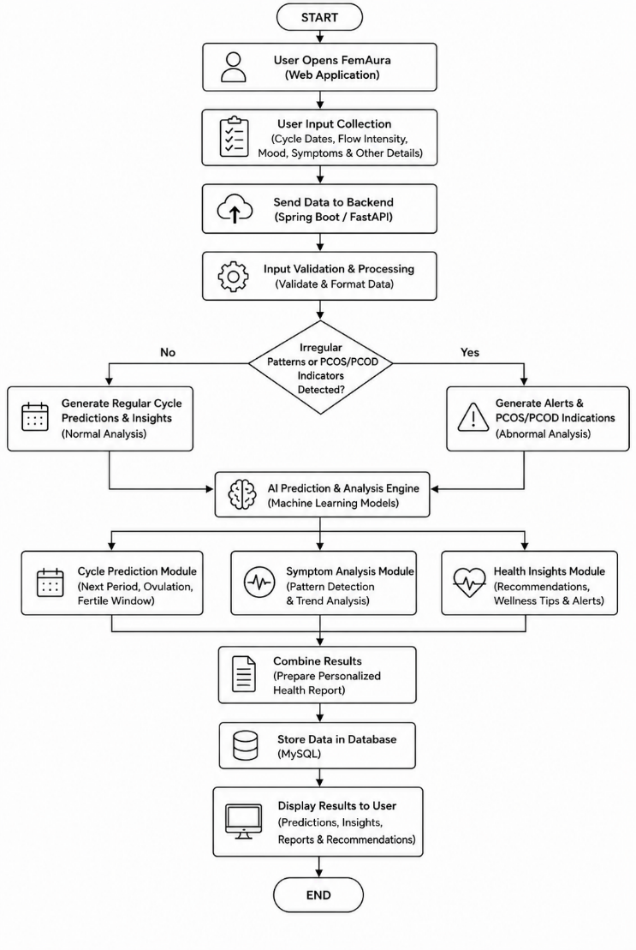
Fig 2: Data Flow
The flowchart represents the working process of the FemAura system from user input to final output generation as shown in [Fig 2]. The process begins when the user opens the web application and enters menstrual details such as cycle dates, flow intensity, mood variations, and symptoms. This information is then sent to the backend system for validation and processing.
After processing the data, the system analyzes menstrual patterns and checks for irregular trends or recurring symptoms. If no abnormal patterns are detected, the system generates regular cycle predictions, ovulation estimates, and fertility window reports. If irregularities or repeated symptoms associated with hormonal imbalance are identified, the system generates health alerts and possible indications related to PCOS or PCOD. This analytical process enables the system to provide personalized and health-focused insights.
The processed data is then passed to the AI prediction and analysis engine, which generates outputs such as cycle prediction reports, symptom analysis, fertility tracking, and reproductive health insights. Each module works independently to generate specific outputs, which are combined into a final health report. The generated results are stored in the database and displayed to the user through the frontend interface.
Finally, the system presents the menstrual predictions and health reports to the user in a simple and organized format. This flowchart demonstrates how the system integrates user input, data processing, AI-based analysis, and report generation to provide intelligent and personalized menstrual health monitoring.

result and analysis

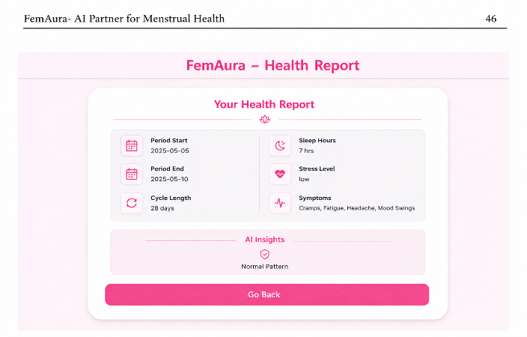

Fig 3: Generated Result
The proposed FemAura system was evaluated by testing it with different menstrual health inputs to analyse its effectiveness in generating personalized cycle predictions and reproductive health insights as shown in [Fig 3]. The system successfully processed multiple parameters, including cycle dates, flow intensity, mood variations, and symptoms. Based on these inputs, the system generated structured predictions, menstrual reports, and health insights tailored to individual users. The results indicate that the system is capable of adapting to different menstrual patterns and providing meaningful outputs. For example, users with regular cycles received accurate menstrual and ovulation predictions, while users with irregular patterns were provided with alerts and symptom-based health analysis.
From a performance perspective, the system demonstrated efficient and responsive behavior. The backend, developed using Spring Boot/FastAPI-based REST APIs, handled user requests with minimal delay, ensuring quick processing of menstrual data and generation of reports. The frontend interface, built using React.js with Material-UI, provided a smooth and interactive user experience, allowing users to easily enter menstrual details and view predictions in an organized format. Additionally, the use of MySQL enabled secure storage and efficient retrieval of user records and prediction history, contributing to overall system performance. The integration of these technologies ensured good usability, scalability, and responsiveness.
In terms of functionality, the system effectively handled multiple menstrual health scenarios. One of the key strengths of the system is its ability to identify irregular cycle patterns and symptom trends associated with hormonal imbalance. When users entered recurring abnormal symptoms or irregular cycle information, the system generated alerts related to possible indicators of PCOS and PCOD and encouraged users to seek medical consultation. This feature improves health awareness and supports early identification of reproductive health concerns. The system also demonstrated consistency in integrating menstrual tracking, prediction, symptom analysis, and health reporting into a single platform, reducing the need for multiple applications.
Furthermore, the system shows potential for practical application in real-world fitness management. The structured output format makes it easy for users to understand and follow the recommended plans. The modular design of the system allows each component fitness, diet, and recovery to function independently while still contributing to a comprehensive solution. This improves maintainability and allows future enhancements to be implemented without affecting the overall system structure. The system’s ability to deliver personalized recommendations in a short amount of time highlights its usefulness for athletes who require quick and reliable guidance.
Despite its effectiveness, the system has certain limitations that can be improved in future work. The current implementation mainly relies on predefined analytical techniques and historical data, which may limit adaptability for highly complex menstrual health conditions. In addition, the system does not currently integrate real-time health monitoring devices or advanced machine learning models for deeper predictive analysis. These limitations indicate the need for future improvements using advanced AI techniques, wearable device integration, and real-time health data analysis..

Overall, the results demonstrate that the proposed FemAura system is capable of providing efficient, reliable, and personalized menstrual health monitoring. It successfully integrates cycle tracking, prediction, symptom analysis, and reproductive health insights into a single platform while delivering outputs that are practical and user-friendly. With future enhancements such as advanced AI integration, mobile support, and real-time health tracking, the system has the potential to evolve into a more intelligent and adaptive menstrual healthcare solution.

V. CONCLUSION
In this paper, an AI-powered menstrual health monitoring system called FemAura has been proposed and developed to provide personalized cycle tracking, menstrual prediction, and reproductive health analysis. The system addresses the limitations of existing menstrual tracking applications by integrating cycle monitoring, symptom analysis, fertility prediction, and early identification of hormonal imbalance indicators such as PCOS and PCOD into a single platform. By considering user-specific inputs such as cycle dates, flow intensity, mood variations, and symptoms, the system generates meaningful health insights and personalized reports tailored to individual users.
The implementation of the system using React.js, Spring Boot/FastAPI, and MySQL ensures efficient performance, scalability, and a user-friendly interface. The results demonstrate that the system is capable of providing reliable menstrual predictions and health analysis while maintaining fast response time and ease of use. The inclusion of irregularity detection and PCOS/PCOD indication analysis further improves the practical value of the system, making it useful for real-world menstrual health monitoring applications.

Although the current system mainly relies on predefined analytical techniques, it provides a strong foundation for future improvements. The system can be enhanced by integrating advanced machine learning models, wearable health device support, and real-time health monitoring for improved prediction accuracy and adaptability. Overall, FemAura offers a simple, secure, and effective solution for personalized menstrual health management, with the potential to support users in improving reproductive health awareness and making informed healthcare decisions.

VI. Future work
The proposed FemAura system provides a strong foundation for intelligent menstrual health monitoring; however, several enhancements can be implemented in the future to improve its functionality, accuracy, and user experience:
- Advanced AI and Deep Learning Models: Future versions can integrate advanced machine learning and deep learning techniques such as LSTM and Transformer-based models to improve menstrual prediction accuracy and reproductive health analysis.
- Wearable Device Integration: The system can be enhanced by integrating wearable health devices and smartwatches to collect real-time health data such as sleep patterns, heart rate, stress levels, and physical activity for more personalized insights.
- Chatbot-Based Assistance: An AI-powered chatbot can be integrated to provide instant guidance, answer menstrual health queries, and offer personalized wellness suggestions, improving user interaction and accessibility.
- Real-Time Health Monitoring: By combining AI models with continuous health data analysis, the system can provide adaptive recommendations and real-time menstrual health tracking.

References
[1] K. Li et al., “Characterizing Physiological and Symptomatic Variation in Menstrual Cycles Using Self-Tracked Data,” NPJ Digital Medicine, 2020
[2] L. Symul et al., “Assessment of Menstrual Health Status and Evolution Through Mobile Apps for Fertility Awareness,” NPJ Digital Medicine, 2019.
[3] S. Selvaraj et al., “Machine Learning Based Prediction of Menstrual Cycle Irregularities for Early Detection of PCOS,” International Journal of Advanced Computer Science and Applications,2022.
[4]H. J. Teede et al., “Recommendations from the International Evidence-Based Guideline for the Assessment and Management of Polycystic Ovary Syndrome,” Human Reproduction, 2018.
[5]A. Desai et al., “An AI-Based System for Menstrual Cycle Prediction and Reproductive Health Monitoring,” International Journal of Computer Applications, 2023
[6] A. H. Balen et al., “The Management of Polycystic Ovary Syndrome: An Update,” Human Reproduction Update, 2016.
[7] S. Patel et al., “A Review of Wearable Sensors and Systems for Monitoring Physical Activity,” Journal of Neuro Engineering and Rehabilitation, 2012.
[8] A. G. Bonomi et al., “Physical Activity Recognition Using a Wearable Accelerometer,” IEEE Transactions on Biomedical Engineering, 2009.

